TAPS Plan for Focused Assessment of Science
Topic: Properties and changing materials | Year 5  Age 9-10 |  | Title: Sugar cube stacks
Working Scientifically  Do: Gather and record data of increasing complexity using tables |  | Concept Context  Know that some materials will dissolve in a liquid to form a solution.
Assessment Focus
- Can children create their own table for recording results?
- Can children record data clearly and accurately?
Activity
Ask children to explore what happens when they place a stack of three sugar cubes in a small pool of coloured water (water with a small amount of food colouring). Pause and discuss what they notice and what they could investigate e.g. does the number of cubes/amount of water make a difference? What if you place a material between the cubes (e.g. paper/foil/cling film)?
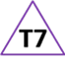
How will you know if it makes a difference – what should we measure? (e.g. time for water to reach x, time to fall). Ask groups to investigate one of their ideas and create their own table to record their findings. (Use fresh water each time if possible to avoid a saturated sugar solution).
Share recorded results, discussing what has been found and reflect on what makes a good table.

Adapting the activity
Support: Question children to ensure they are clear about what they are changing and what they are measuring. Remind children to provide table titles so that they can be understood by others.
Extension: Repeat readings or try a different measure to check results.
Other ideas: Investigate different types of sugar, different temperatures of water…

Questions to support discussion
- What are you changing?
- What will you measuring?
- How are you recording your results?
- What are you putting in this column?
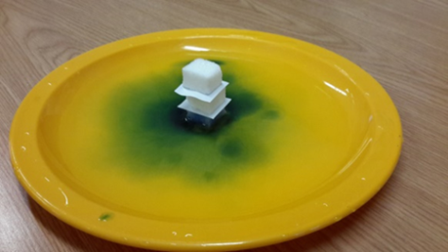
- Can you explain what your table shows?
- How clear is this table?
- How could the table be made more clear?
Assessment Indicators
Not yet met: Children note times, but recording is not be clear, e.g. measuring time to absorb or time to fall/dissolve.

Meeting: Pupil recordings clearly show what was investigated. Results are recorded systematically in a table.

Possible ways of going further: The results table follows the science format of ‘change’ in the left-column and ‘measure’ in the right column(s). Pupils recognise the need to repeat measures if they had more time and/or problems with the reliability of their data e.g. it was hard to tell when it had fallen so we should have done it again to check.
Teacher box 7 - time to reflect. See TAPS pyramid for more examples.

