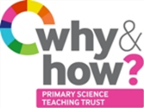
TAPS Plan for Focused Assessment of Science
Topic: Evolution and inheritance | Year 6  Age 10-11 | Title: Fossil habitats
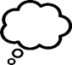  Working Scientifically  Review: Identifying scientific evidence that has been used to support or refute ideas or arguments. | Concept Context  Recognise that living things have changed over time and that fossils provide information about living things that inhabited the Earth millions of years ago.
Assessment Focus
- Can children use evidence (from fossils or research) to develop ideas?
- Can children discuss whether evidence supports ideas?
Activity Today we are going to be palaeontologists.
Show a picture of a fossilised skeleton/creature and discuss the children’s ideas about fossils, what it was, what it ate, where it lived etc. (Could provide only one part to start with, or parts to different groups, to show how we only have part of the information). Discuss strong/weak evidence e.g. strong evidence that has skeleton/teeth etc, place where fossil was found suggests habitat, similarities with modern creatures suggest colour etc.
Provide children with photos or real/resin fossils (trilobite, ammonite, ichthyosaurus etc, plus any found locally or linked/displayed at local museums). Ask them to use the fossils and their own research to develop ideas about the creatures e.g. labelled drawing with size, possible appearance, diet, habitat, what other fossils could exist eg what prints could be left behind.
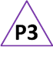
Could colour code or star ideas for which there is the strongest evidence.

Adapting the activity
Support: Provide examples of animals alive today that have similar physical characteristics.
Extension: Make food webs for the prehistoric creatures using secondary sources.
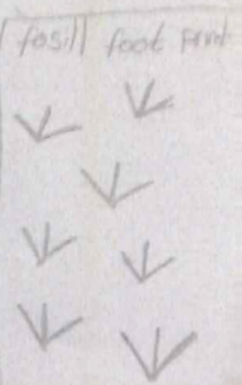
Other ideas: research palaeontologists, top trumps of fossils, models to demonstrate, explanation writing about fossil formation.

Key Questions
- What is a fossil? How was it made? (The rock has filled the gap where the animal was, so not the remains of an animal).
- What do you think it looked like? How can you tell?
- What do you think it ate? How can you tell?
- Where do you think it lived? How can you tell?
- If the creature looked like that, what fossils could be left behind?
Assessment Indicators
Not yet met: Ideas about the creature are limited or lacking in use of evidence from fossil, research or comparisons with modern animals.

Meeting: Can explain how fossils are formed. Can identify evidence to support ideas, from fossil, research or comparisons with modern animals.

Exceeding: Considers what can be known about appearance, habits and habitats from fossil evidence. Describes potential sources of error.
Pupil box 3 - assess own ideas. See TAPS pyramid for more examples.

